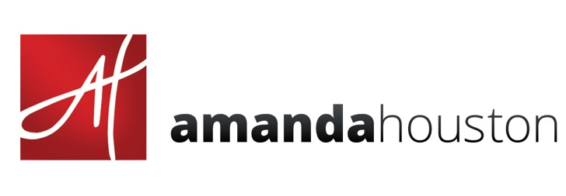
GENERAL SUPPLY LIST
for Pastel Workshops

__x__Check off as you go.
PASTELS: As many as you can bring, with a mixture of soft and hard pastels, with a range of brights, darks and grey tones. You can use any brand you have and may want to pick up extras, esp. in the darks and neutrals. NO oil pastels.
__ SOFT PASTELS: Any brand you have. I have my own collection through Richeson: (Amanda Houston 80 pc. Landscape essentials set and a 40 pc. Neutral essentials set) I also use Terry Ludwig for darks (v100x, B3560, G540,R160),
__ HARD PASTELS:
(10-30): Girault or NUPastel - a variety of darks and lights. You can pick up hard pastels by the stick. These are my favorite work horse colors for skies and water and scumbling techniques.
NUPastel: Either the 24 or 48pc set or these are my favorite individual sticks: 207,212,305,244
Girault: 199,178,463,375

__DRAWING BOARD: Gator-board (preferably black but white will work), foam core or Masonite board for taping your papers and inspiration references on. (3/16 “ is fine. No need for The thicker version. This is an affordable way without getting a huge 4x8’ case.
https://www.uline.com/BL_872/Gatorfoam-Board)

___ PAPERS: If you have a favorite, please bring it. I will be demoing on LaCarte paper (Sienna color), Art Spectrum Colorfix (terracotta, raw seinna), and LUX Archival). You can buy a large sheet and cut them down into smaller workable sizes for the class: 8x10, 9x12, 11x14 or 12x16 for the class. We will focus on lots of small work. Bring at least enough for 8-10 small paintings. I encourage students to try surfaces they haven’t tried.
___EASEL of YOUR CHOICE: Studio easels are provided. Bring your own if you have a favorite.

MISC. SUPPLIES:
___ Sketchbook: Small personal sketchbook. MUST HAVE! Any size. Amanda likes “Strathmore Toned sketchbooks” in either gray or tan for doing thumbnail value studies.
___ Selection of pencils: a variety of hardness: (HB, 2B, 4B, 6B) (optional)
___ Charcoal pencils (white, lt, med, dark)for value studies
OR
___ Tombow or Faber-Castell grey set of 4 pens (for value sketches) (optional)
___ Kneaded eraser
___ vine charcoal for sketching on your surface (soft or very soft)
___ Black Artist tape 3/4"-1" or Blue painters
___ wet wipes
___ View Catcher or composition finder (by Guerrilla Painter) (optional)
___ Exacto Knife or straight edge to cut (by Olfa)
___ 2 medium sized Tupperware containers, one filled with cheap cornmeal (to clean your pastels)
___ Brush assortment: 1” small cheap hardware brush, 1-2 different sized synthetic brushes from “Snap!” by Princeton or Simply Simon: ¾” flat or stroke (optional but I like them because they are cheap)
___ Small container of denatured Alcohol or mineral spirits for doing underpainting techniques (water works in a pinch too) and a small container to put it in (old tuna can works fine)
___ Pad of Newsprint paper 18x24 (optional)
___ Spray Fixative: Lascaux for finish work or any workable fixative for working (optional)
___ Glassine Paper: to put over your finished work to protect it in transport. Or sandwich between two pieces of gatorboard. (optional)
___ Photo references of landscapes to bring for inspiration (either on an ipad or printed out) of what you want to paint. KEEP IT SIMPLE. Think 3-5 big shapes. No intricate detailed photos please. Instructor will have inspirational photos as well.

